

Jurnal Pendidikan dan Konseling
UNIVERSITAS Pah l a w a N
Volume 5 Nomor 1 Tahun 2023
E-ISSN: 2685-936X dan P-ISSN: 2685-9351
Universitas Pahlawan Tuanku Tambusai

Students/ Perception on Online Learning during the Covid-19 Pandemic

Heni Novita Sari1, Putri Nurmaulida2
1,2English Department, FKIP, University of Muhammadiyah Prof. Dr. Hamka
Email:henisalman.17@gmail.com1,putrinurmaulida85@gmail.com2

Abstrak
Pandemi COVID-19 memaksa pemerintah Indonesia melalui Kementerian Pendidikan dan Kebudayaan untuk menerapkan kebijakan memindahkan ruang kelas tatap muka ke pembelajaran daring. Tujuan penelitian ini adalah untuk mengetahui persepsi siswa terhadap pembelajaran daring pada masa pandemi covid-19 di SMKS IPTEK sanggabuana. Penelitian ini menggunakan metode deskriptif-kualitatif. dalam pengumpulan data, peneliti menggunakan kuesioner, ada 30 siswa dari kelas OTKP (Otomatisasi dan Tata Kelola Perkantoran) SMKS IPTEK Sanggabuana berpartisipasi dalam penelitian ini. Berdasarkan analisis data, peneliti menemukan kesimpulan persepsi siswa terhadap pembelajaran online selama pandemi covid-19 mendapat persepsi positif karena fleksibel dan efektif. Hal ini terlihat dari persentase data, 56% siswa menjawab setuju for interaktivitas, 58% setuju for kemandirian, 38% setuju for aksesibilitas, dan 56% siswa menjawab setuju untuk pengayaan. Artinya, siswa dapat mengadaptasi sistem pembelajaran daring untuk sementara menggantikan pembelajaran konvensional selama pandemi Covid-19. Meskipun siswa menemukan kesulitan untuk memahami material dalam pembelajaran online.
Kata Kunci: Persepsi Siswa, Pembelajaran Daring, Pandemi Covid-19

Abstract
The pandemic of COVID-19 has forced the Indonesian government through its Ministry of Education and Culture to implement policies moving face-to-face classroom to online learning. The aim of this research is to knowing the students' perception on online learning during the covid-19 pandemic at SMKS IPTEK sanggabuana. This research used a descriptive-qualitative method. in collecting the data, the researcher used questionnaire, there were 30 students from OTKP (Otomatisasi dan Tata Kelola Perkantoran/Automation and Office Governance) class of SMKS IPTEK Sanggabuana participated in this research. Based on the analysis the data, the researcher found conclusion of students' perception toward online learning during the covid-19 pandemic gets positive perception because it is flexible and effective. This can be seen from percentage of the data, 56% students answered agree for interctivity, 58% agree in independence, 38% agree in accessibility, and 56% students answered agree in enrichment. It means students can adapt the online learning system to temporarily replacing conventional learning during Covid- 19 pandemic. Even though the students found the difficulties to understand the material in online learning. Keywords: Students' Perception, Online Learning, Covid-19 Pandemic

INTRODUCTION
The Covid-19 virus was first detected in Wuhan, China, in late December 2019. This virus has since spread to various parts of the world, including Indonesia. Since then, the World Health Organization (WHO) has declared a global pandemic. The pandemic has had a significant impact on the economic and social sectors, but also the education sector. The Indonesian government has taken a policy to break the transmission chain of the pandemic. According to Jamaluddin et al. (2020), the community, as well as pupils and teachers, must carry out all activities at home, such as work and study or many activities from home. All of these things have been done to reduce and stop the transmission of Covid-19 due to the increase in the number of pandemic patients in Indonesia.
The world of education follows government policies and immediately makes adjusted plans by implementing an online learning system. According to Arifa (2020), during the emergency time of the spread of the pandemic, the implementation of education policies regarding home learning arrangements was carried out in Circular Letter 4 of 2020. The learning process has been done using the Internet rather than directly in class.
The government issued an online learning policy to continue to realize educational goals in Indonesia amid the pandemic. According to Retnoningsih (2020), Online Learning is a learning process supported and facilitated by communication and information technology. That means online Learning is some pattern of distance education in which pupils access their course material through the Internet while being physically apart from one another and still being able to communicate and engage. Students and teachers learning with this method can access and submit subject matter widely from various sources, increasing the efficiency and interactivity of Learning.
However, students still showed many reactions to changes in-person session learning methods to online. They are related to short learning times, increased assignments, hostile signal conditions, and unused quotas. Meanwhile, Baity (2018) States that Perception is an individual's initial process of translating sensory impressions in giving meaning to the environment. It suggests that Perception is a person's response to what he receives from their environment. In addition, the online learning process currently being implemented is an impromptu system that demands pupils' ability to master and use technology well. Perception is an internal process that allows us to select and interpret stimuli from the environment that affect our behavior. Another definition of Perception is the activity of the soul that enables man to recognize the stimuli that reach him through his sense organs; with this ability, humans recognize their life environment (Sabri, 199). It implies that Perception is the process of comprehending and assigning significance to data about a stimulus.
Implementing online Learning is more challenging than expected. Pupils face various obstacles during online Learning. Kusnayat (2020), Indonesian universities, in particular, need more time to be ready to use learning technology with online systems. In addition, several cases were obtained with this online learning system: pupils who experienced stress and mental disorders and could not follow the learning process properly. It means that learning with an online system makes pupils stressed by their need for more understanding of technology.
Online Learning has been implemented in an education unit at the junior high school level of SMKS IPTEK Sanggabuana. However, the application of online Learning still encounters various obstacles. The most prominent block is the need for more media for Online Learning. Many students have to watch learning videos given by the teacher on one laptop, so the material obtained could be more optimal. In addition, the teacher's intensity in delivering material in one of the subjects is reduced, and it is difficult for student to understand.
According to the information presented above, the writer can draw the following conclusion about online learning systems, the majority of those who stated that they found online learning challenging believe that it is ineffective and that pupils struggle to comprehend the material because it cannot be explained to them personally and in detail by them or other people. Hopefully, this research will be a guide for readers and an evaluation material that can immediately get solutions to reduce the problems experienced by students while using this online learning system. So that online Learning will be maximized in the future and learning objectives can be achieved. From the explanation above, the writer has been motivated to determine the perception of students of SMKS IPTEK Sanggabuana. The writer gives the title of this paper, “Students' Perception on Online Learning during the Covid-19 Pandemic”.

METHOD
The study uses qualitative descriptive methods. Descriptive research is used to analyze data by describing the data that has been collected as it is without intending to make conclusions that apply to the general public and its generalizations (Sugiyono, 2010). According to Kriyantono (2009), qualitative research intends to understand the phenomena experienced by the subject of study (for example, behavior, Perception, motivation, action, etc.). This study aims to analyze and explain perception of student of online learning during the pandemic at SMKS IPTEK Sanggabuana descriptively and supported by percentage figures. The participant in this study were all students at SMKS IPTEK Sanggabuana. In this case, the subject of this research was class OTKP in the 2020/2021 academic year. There were around 30 students in the class. The researcher only took one class.
The research used a questionnaire to collect data. The questionnaire is a list of questions given to others willing to respond per users' request (Arikunto, 2010). The author made a questionnaire in the form of Google Forms consisting of 23 items and distributed it through students' WhatsApp groups to collect the data online. The questionnaire was shared with 30 respondents. The questionnaire in this study used the Likert-Scales to score perception of student. Based on Sugiyono (2014), the Likert Scale measures opinions, attitudes, and perceptions of a group or person of people about social phenomena. Hence, this method is used to find the perception of student of Online Learning during the covid -19 pandemic at SMKS IPTEK Sanggabuana. To analyze the data, the researcher gave the questionnaires to students. This step was conducted to know what students' perception towards online learning during Covid-19 pandemic. From the data display, the researcher was drawing a conclusion in order to answer the research.

RESULT AND DISCUSSION
This research has answered the research question. The research question is what are perception of student of Online Learning during the pandemic at SMKS IPTEK Sanggabuana in the academic 2020/2021 academic year? The researcher has analyzed their Perception and categorized them into four aspects. There are interactivity, independency, accessibility, and enrichment.
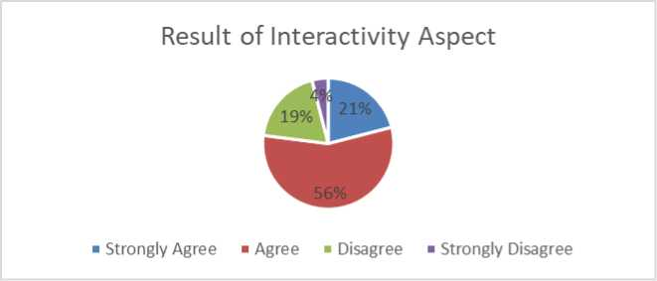

Interactivity focuses on communication which is the key to interaction between students and teachers. The communication should be available to be reached either directly, such as messenger or chat, or via forum or mailings indirectly. In this research, the case of interactivity in online Learning makes students feel less nervous about interacting with their classmates and teacher during discussions. (Rusman, et al., 2011). Besides, Online learning media like Zoom, Google classroom, and WhatsApp, which are used in teaching and Learning, helps teachers and students interact more easily than face-to- face. Lastly, the teacher can give assignments and instructions and ask students questions anytime. These relate to Mitchel et al (2013), who said online Learning could build efficient discussions between students and teachers. Also, students interact and discuss with each other without going through the teacher. Therefore, interactions can remain involved in learning even during the limited time of COVID19.

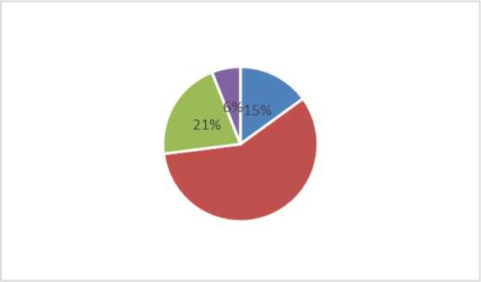
58%
Result of Independence Aspect
■ Strongly Agree ■ Agree ■ Disagree ■ strongly Disagree
The independence of Online Learning is focused on student-centeredness with the help of flexibility in terms of time, location, lecturers, and teaching materials. The results of student responses show that online Learning can train students' independence in Learning. This is evidenced by the first that online Learning makes students want to learn more because they need a lot of references in Learning. Second, online Learning makes it easier for students to do assignments because of the facilities provided by technology. Third, online Learning can train students' independence because they become more responsible in Learning. Furthermore, online Learning can streamline students' time in Learning. The last is that most students in online Learning always show up on time. Access to online Learning is not only for improving skills but also for providing flexibility (Woodman, 2003).
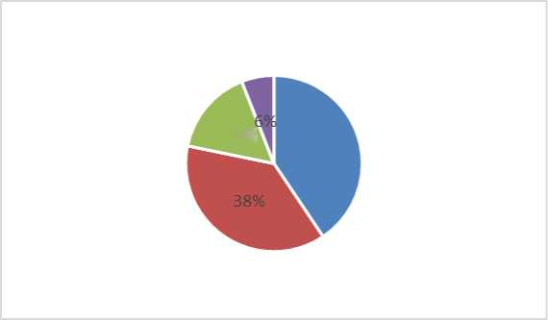
16%
40%
Result of Accessibility Aspect
■ Strongly Agree ■ Agree ■ Disagree ■ strongly Disagree
Inaccessibility, according to the results of the accessibility questionnaire, is the aspect of asking whether there is good or impaired access. Good accessibility is online learning can access course materials at any time, help students optimized accessing the material, provide the same material as face- to-face classes, and make learning English easier. It is not good that the teacher can still explain the same point of the material in Online Learning, and it is not easy to understand the material in Online Learning. Aware of the changes from conventional Learning to Online Learning, the teaching and material should meet the needs and wants of the learners (Tomlinson, 2010). It means that the material given does not develop students' knowledge and skills.
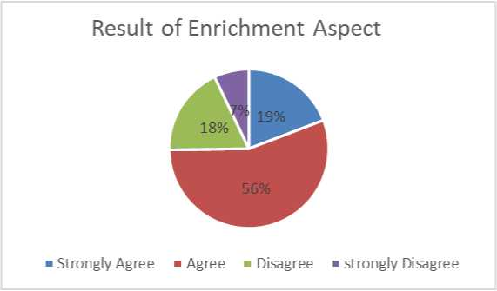

The result of enrichment aspects shows that the teacher always explains the material in online Learning before giving the assignment. The teacher always asks questions and opens discussions in online learning classes. Online Learning makes it easier to understand each material. An online learning class is better than an in-person session class. Online learning classes are more interesting than inperson session. Online learning class makes them pay more attention to the course than an in-person session class. Learning activities, such presentation of lecture materials and training materials as enrichment, are part of online Learning. Information technology tools that use in that situation, such as animation, simulation, and video streaming, help to improve computer-based learning further and make content materials available on the Internet (Almosa, 2005).

CONCLUSION
Online Learning gives a big chance for students to access their material anytime and anywhere. The benefit comes from the media of Online Learning which help the students to study and attend class as usual. However, the online learning process does not have so many differences in the learning activity. For example, the students still feel the same about expressing their thought in the middle of the study or in the discussion session. They are not gain any confidence and are not so afraid to give an opinion. And also, students' motivation and responsibility for studying in Online Learning are the same as their previous. In the process of study, the student found that whether in online Learning or classroom-based Learning, the depth of material is still the same. In conclusion, perception of student of Online Learning is quite good because, based on their experience, they found that most of the aspect of online Learning is the same as classroom-based Learning.

REFERENCES
Jamaluddin, D., Ratnasih, T., Gunawan, H., & Paujiah, E. 2020. Pembelajaran Daring Masa Pandemik Covid- 19 Pada Calon Guru: Hambatan, Solusi Dan Proyeksi. Jurnal PIAUD, Volume 4, Nomor 2, 5.
Arifa, F. N. 2020. Tantangan Pelaksanaan Kebijakan Belajar dari Rumah dalam Masa Darurat Covid-19. Info Singkat Bidang Kesejahteraan Sosial, 7(1), 14.BAB III.
Sugiyono. (2014). Metode Penelitian Kuantitatif, Kualitatif, Dan Kombinasi (Mixed Methode). Bandung: CV Alfabeta.
Kriyantono, R. (2009). Teknik Praktis Riset dan Komunikasi. Penerbit Kencana, Jakarta. Sugiyono, S. (2010). Metode Penelitian Kuantitatif Kualitatif dan R&D. Alfabeta. Arikunto, S. (2013). Prosedur penelitian pendidikan. Rineka Cipta.
Yuniarti Ratna, Hartati Widya 2020: Persepsi Mahasiswa Tentang Penerapan E- Learning Pada Masa Darurat Covid-19.
Rusman, et al 2011. Pembelajaran berbasis teknologi informasi dan komunikasi, mengembangkan profesionalitas guru. Jakarta: PT. Raja Grafindo.
Miles, Matthew B. and A. Michael Huberman. 1994. Qualitative Data Analysis. Thousand Oaks. Sage Publications.
Woodman, K. 2003. The Real Benefit of Online Learning. International Journal Learning Volume 10, 20013 Tomlinson, B. 2010. Principles and procedures of materials development. In N. Harwood (ed.) Materials in
ELT: Theory and Practice. Cambridge: Cambridge University Press.
Almosa, A. & Almubarak, A. 2005. E-learning Foundations and Applications, Saudi Arabia:Riyadh.
Thoha, M. 2011. Perilaku Organisasi, Konsep dasar, dan Aplikasi. Jakarta: PT. Raja Grafindo Persada.
Bilfaqih, Y., & Qomarudin, M. 2015. Esensi Penyusunan Materi Daring Untuk Pendidikan dan Pelatihan. Yogyakarta: DeePublish.
Walgito, B. 2010. Pengantar Psikologi Umum. Yogyakarta: Andi Offset.
Irawati, R., & Santaria, R. 2020. Persepsi Siswa SMAN 1 Palopo Terhadap Pelaksanaan Pembelajaran Daring Mata Pelajaran Kimia. Jurnal Studi Guru dan Pembelajaran, 3(2), 265.
Erlina Sulistiyawati. (2020). Persepsi Siswa Terharap Pembelajaran Daring Pada Mata Pelajaran Bahasa Indonesia di Madrasah Aliyah Negeri 2 Surakarta.
Agung, A. S. N., & Surtikanti, M. W. (2020). Students' Perception of Online Learning during COVID-19 Pandemic: A Case Study on the English Students of STKIP Pamane Talino. SOSHUM: Jurnal Sosial Dan Humaniora, 10(2), 225-235. https://doi.org/10.31940/soshum.v10i2.1316.
Sugiyono. (2014). Metode Penelitian Kuantitatif, Kualitatif, Dan Kombinasi (Mixed Methode). Bandung: CV Alfabeta.
Mitchel, R., Myles, F., Masdem, E. 2013. Second language learning theories: Interaction in second language learning. Routledge, London.

